04. Zendesk - Case Handling and Best Practices
Audience: [LOB: Fraud Support]
- Overview
- What is Zendesk?
- Zendesk tool overview
- Communication & Notes
- How to work on a ticket?
- How to handle duplicate inquiries from the same organization?
- Merging tickets
- Translation paths & Review protocols
- Process map

Overview
This article explains how to manage Fraud Support tickets in Zendesk, with guidance on ticket handling, customer communication, internal notes, escalations, and ticket status management.

What is Zendesk?
Zendesk is the customer relationship management (CRM) and ticketing platform used by the Fraud Support team to manage support requests. It serves as the primary communication channel between agents and owners, users, and reviewers, with tickets routed based on factors such as language, priority, and agent skill set.

Zendesk tool overview
Left-side panel
- The left section of Zendesk contains the fields that agents must complete while handling a case. This section includes mandatory information such as the Location ID, Ticket Reason, and Review ID.
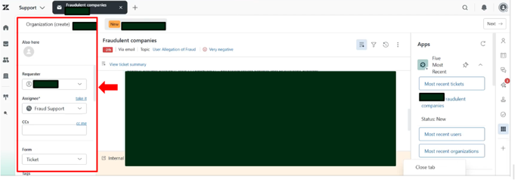
- Filling out the fields in the left section enables agents to populate the exact Review ID, Location ID, and other relevant information directly in the tool.
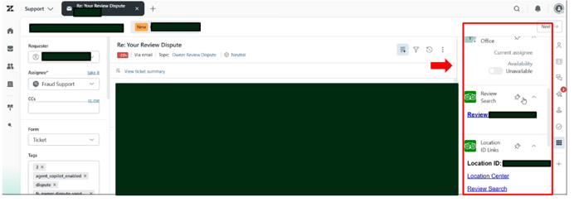
- Additionally, agents should check the following options based on the findings of the case investigation.
  - Red Badge on Property: Check this box when a Red Badge is posted on the property page.
  - Penalty Mitigated: Check this box when a penalty mitigation is applied.
  - Escalate to Tier 2: Check this box whenever escalating a case to Tier 2.
  - Property Sweep: Check this box whenever a sweep is performed or requested.
  - Escalate to SGS Second Opinion: Check this box whenever getting a second opinion from your Team leads and QA’s
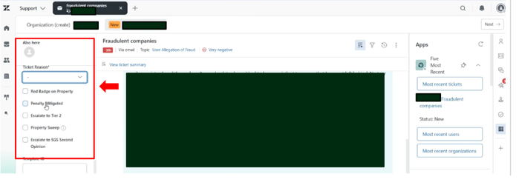
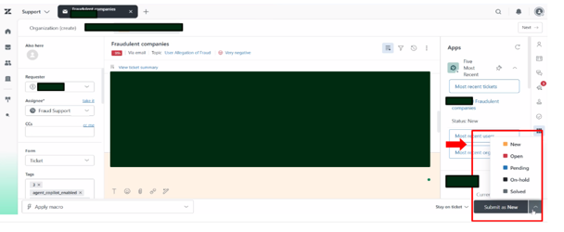
Ticket status definitions
Status | Definitions
🟨New | This status denotes that the ticket is unassigned. Once it has been assigned to an agent, it cannot be changed back to this status.
🟥Open | The ticket has been assigned and is currently being worked on.
🟦Pending | The agent has responded and is waiting for additional information from the requester.
⬛On hold | The agent is awaiting a response or action from another internal team.
⬜Solved | The case has been resolved, and no further action is required.
Closed | The ticket is automatically closed by the system after a period of inactivity.

Communication & Notes
- Public Reply (white): This field is used to communicate directly with the requester who submitted the ticket. Always review the response carefully before sending, as it will be visible to the requester.
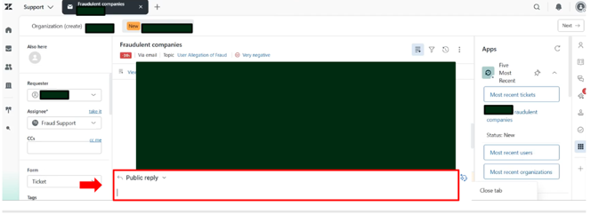
- Internal Note (yellow):
This section is used to document the research, decisions, evidence, and actions taken during the investigation. Internal notes are visible only to Tripadvisor employees.
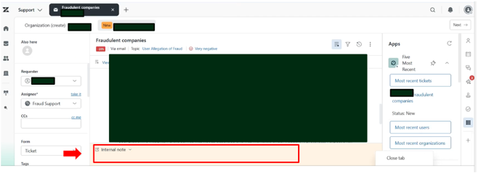
Do’s and Dont’s
Do’s | Dont’s
Ensure all communication shared with the end-user is appropriate for external audiences. | Do not include personal opinions or jokes in responses to end-users.
Convert a public reply into a private comment if it contains internal-only information. | Do not include screenshots from internal files.
Do not forward or quote communications from other Tripadvisor teams or individual Tripadvisor team members to the end-user.
Note: Failure to comply with these requirements constitutes a critical error
Importance of Internal Notes
- Internal Notes are used to document all the case investigations and actions taken on a case.
- They provide the reasoning behind agent decisions and ensure that all relevant information is readily available to improve quality, increase productivity, and support other departments during legal or Public relations (PR) escalations.
What to include | What not to include
- Explanations of research, decisions, and actions. | - Personal opinions about the requester or situation.
- Review IDs and Location IDs | - Overly casual, cryptic, or humorous language
- Removal reasons and translations of evidence that cannot be copied/pasted. | - Screenshots or attachments.
Examples of well-documented internal notes:  - Looked at reviews submitted between Sept. 1st and Sept. 30th, found pattern of formulaic email addresses from 1st time users, removed as SB  - Sent incentive survey for all reviews submitted since August 1st  - Removed review <enter review ID> for suspected vandalism due to pattern of user submission on attributes | Examples of poorly documented internal notes:  - Performed property sweep  - Sent incentive surveys  - Removed review reported by owner  - Checked the account  - Investigated the issue  - Contacted the owner
Macros used for escalations
- To FS Tier 2 - When escalating to Tier 2
- To Customer Support - When escalating to CS
- To Investigations - When escalating to investigations

How to work on a ticket?
Important:
- Agents should always start their day by processing reopened tickets before moving on to new ones.
- Team Leads will direct weekly queue assignments based on the current rotation schedule.
- Agents are responsible for monitoring and working out of their assigned queue(s) for that week, which will be selected from the three primary workflows:
  - Owner Sourced tickets
  - User Sourced Tickets
  - FS Main Queue.
Preliminary checklist
- Before working on a ticket, check Most recent tickets to determine whether an active ticket already exists for the same property, requester, and issue.
- If an active ticket is found, merge the tickets accordingly. Refer to the section Merging Tickets.
Reminder:
- Do not make assumptions. Base every decision on the evidence available in the current case.
- Use the latest guidelines and procedures. Avoid relying on memory or outdated practices.
- Treat each case independently. Do not let previous cases or personal opinions influence your decision.
- Do not cherry-pick or nitpick tickets. Review all relevant recent tickets before taking action.
Assign a ticket
- Assign the ticket to yourself by clicking "take it".
- Ensure "Ticket" is selected as the Form.
- Enter Location ID and Review IDs.
- Select the correct Ticket Reason.
- Submit the ticket as "Open" to save changes.
Note: Zendesk conversations are shown in chronological order, top to bottom. This means that the most up-to-date response will be at the bottom of an ongoing conversation.
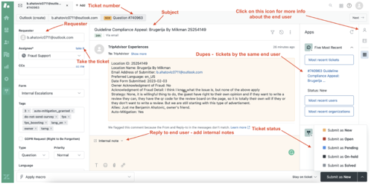

How to handle duplicate inquiries from the same organization?
When multiple staff members from the same organization contact us regarding the same issue, do not merge the tickets. Instead, respond to each requester individually.
Suggested response
- “I noticed we have received other inquiries from your team regarding this matter. To ensure we provide the most efficient support, please designate a single point of contact to handle this correspondence moving forward.”
- “I understand that several members of your organization have reached out to us regarding this issue, and we appreciate everyone's efforts to help resolve it. To ensure clear, consistent communication and prevent duplicate updates, we kindly ask that your organization nominate one primary contact for this case.”
- “I noticed that we have received multiple inquiries from members of your organization regarding the same issue. To streamline communication and ensure everyone receives consistent updates, please have one designated representative communicate with us on behalf of your organization.”

Merging tickets
- Why do we merge tickets?
The purpose of merging two or more tickets is to prevent multiple agents from handling the same issue with an owner or user/reviewer. This avoids duplicate effort and mitigates the chances of potential confusion.
- What to do if a duplicate ticket is open?
If an agent identifies a duplicate ticket that is still open, they should merge the two tickets.
However, if the duplicate has already been solved, the agent should close the new ticket and apply the following internal comment:
"Addressed in ticket XXXXX, setting ticket to solved as no further action is needed."
When to Merge | When not to Merge
- Multiple tickets from the same requester regarding the same topic. | - Tickets from an owner and a user, even if they are related to the same review/situation.  - Tickets from two different owners of the same property.  - Tickets from the same owner but for 2 different properties/reviews with different issues or fraud pattern.
How to Merge:
- Select "Merge into another ticket" from the three-dots menu (right top, close to email subject)
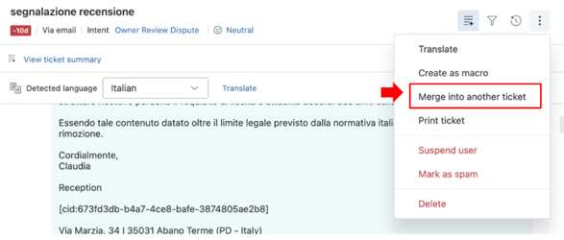
- Enter the Target Ticket ID.
- Click "Merge".
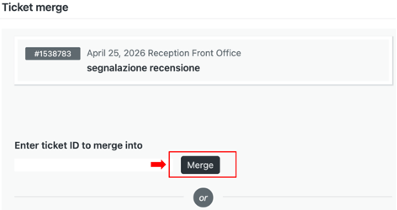
Operational procedures based on specific scenarios
Scenario | Procedure
Spam | - Leave an internal comment "Ticket is spam" and/or use the "Mark as spam" tool.
Agents OOO | - For absences > 2 days, toggle 'Out of Office' and tick 'Agent Out' on their profile.  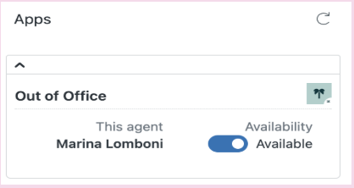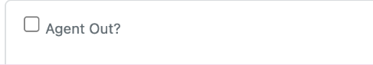
Attachments | - Use tools like Nimbus or Snip board for URLs; never attach internal files to your internal comment or the end user might be able to see them.
End-users send an autoreply | - If an automated reply is received which is completely irrelevant to the previous message, revert the ticket to its previous status (e.g., set it to Solved if it was previously solved, or pending if awaiting a response from the requester).  - Leave an internal note explaining the reason for the status update.
Responses That Look Empty (But ), finding the sender's email address, finding person in cc: | - Responses from owners or users may occasionally appear empty, with no visible text or other information. In such cases, the sender's email address and any recipients in CC may also not be displayed.  - To view the original message, click the three-dot menu at the top-right corner of the end user's response, next to their name, and select View Original Email.  - This will open a pop-up window displaying the original email content.  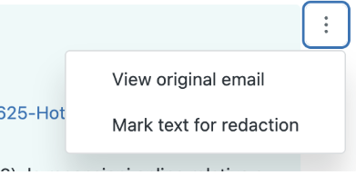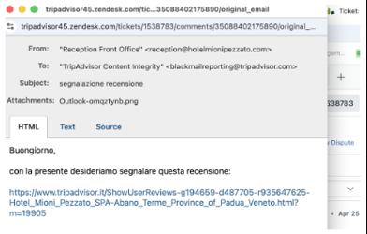
Translations | - The default Zendesk (ZD) account language is English.  - If a ticket is received in a language other than English, use the Translate option to translate the end user's inquiry, eliminating the need to use an external translation service.  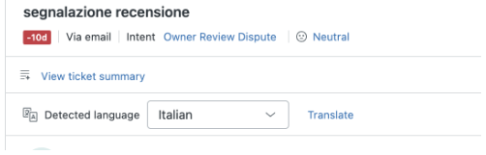

Translation paths & Review protocols
Internal notes rule: If the translation tool is used, always paste the original English response in the internal note before sending the translated reply to the end user.
Depending on how the response is generated, apply the correct review protocol:
Path A: Using auto-generated replies
Scenario | Review protocol
- You are utilizing an automated, pre-written response generated entirely by the Auto Assist system. | - You MUST thoroughly review the foreign language message before sending. As the content is completely system-generated and you did not author the original framework, a manual audit is required to ensure context and accuracy.
Path B: Translating your own English draft
Scenario | Review protocol
- You have manually typed and customized your own custom response in English and are using the tool to translate it into the user's language. | - You are NOT required to double-check or audit the final AI-generated foreign language translation. Since you authored the source text yourself, the standard translation check is waived.
While skipping tickets should generally be avoided, agents who must do so are required to log a specific reason. This tracking helps identify operational gaps and improve our overall workflow.

Process map
